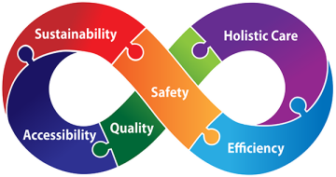

**Telephone your chosen hub for on the day appointments**

**Or**

**Pre book appointments at the Unity hub via your own practice – please speak to reception.**

**Unity Christmas opening 2019**

**Christmas Eve – 4pm – 8pm**

**Christmas day – 9am-12pm**

**Boxing Day – 9am – 12pm**

**New Year’s Eve – 4pm – 8pm**

**New Year’s Day – 9am - 12pm**

**U N I T Y**

**The Unity hubs are based at:**

**Pennfields Health Centre  
Upper Zoar Street  
Pennfields  
Wolverhampton  
*WV3 0JH***

**Telephone 01902 446688**

**Ashmore Park Health Centre,**

**339 Griffiths Dr,**

**Wolverhampton**

**WV11 2LH**

**Telephone 01902 732442**