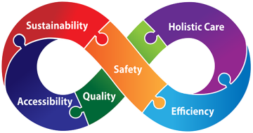

**U N I T Y**

**August Bank holiday opening 2021**

|  |  |
| --- | --- |
| **Saturday 28TH August** | **8am -2pm** |
| **Sunday – 29th August** | **8am -2pm** |
| **Bank holiday Monday 30th August** | **9am -12pm** |

**The Unity hub is based at:**

**Pennfields Health Centre  
Upper Zoar Street  
Pennfields  
Wolverhampton  
*WV3 0JH***

**Telephone 01902 446688**

**Telephone for on the day appointments**

**Or Pre book appointments via your own practice**

Service provided on behalf of the following practices: