**

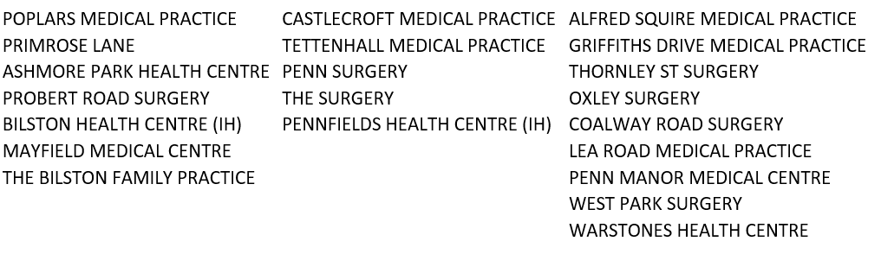



[This Photo](https://www.pngall.com/easter-flower-png/download/1902) by Unknown Author is licensed under [CC BY-NC](https://creativecommons.org/licenses/by-nc/3.0/)

|  |  |
| --- | --- |
| **Good Friday- 29th March** | **9am -12pm** |
| **Saturday-30th March** | **9am -5pm** |
| **Easter Sunday-31st March** | **9am -2pm** |
| **Bank holiday Monday 1st April** | **9am -12pm** |

**Telephone for on the day appointments**

**Or Pre book appointments via your own practice**

**The Unity hub is based at:**

**Pennfields Health Centre  
Upper Zoar Street  
Pennfields  
Wolverhampton  
*WV3 0JH***

**Telephone 01902 446688**

Service provided on behalf of the following practices:

**U N I T Y**

**Unity Easter opening 2024**